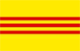
⬇⬇⬇
Dinner in Honor of
Arizona Viet Nam Veterans
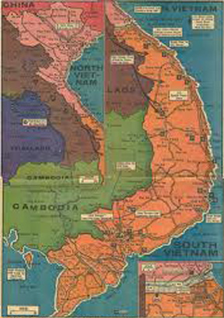

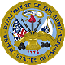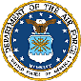
Wild Horse Pass Hotel & Casino
5040 Wild Horse Pass Blvd. Chandler, AZ
October 20, 2012

