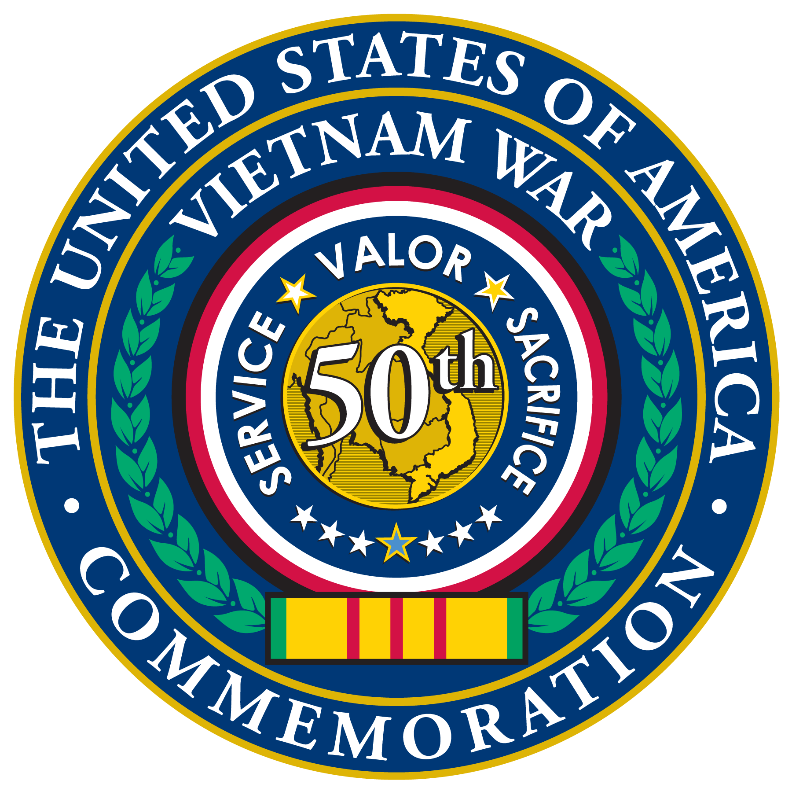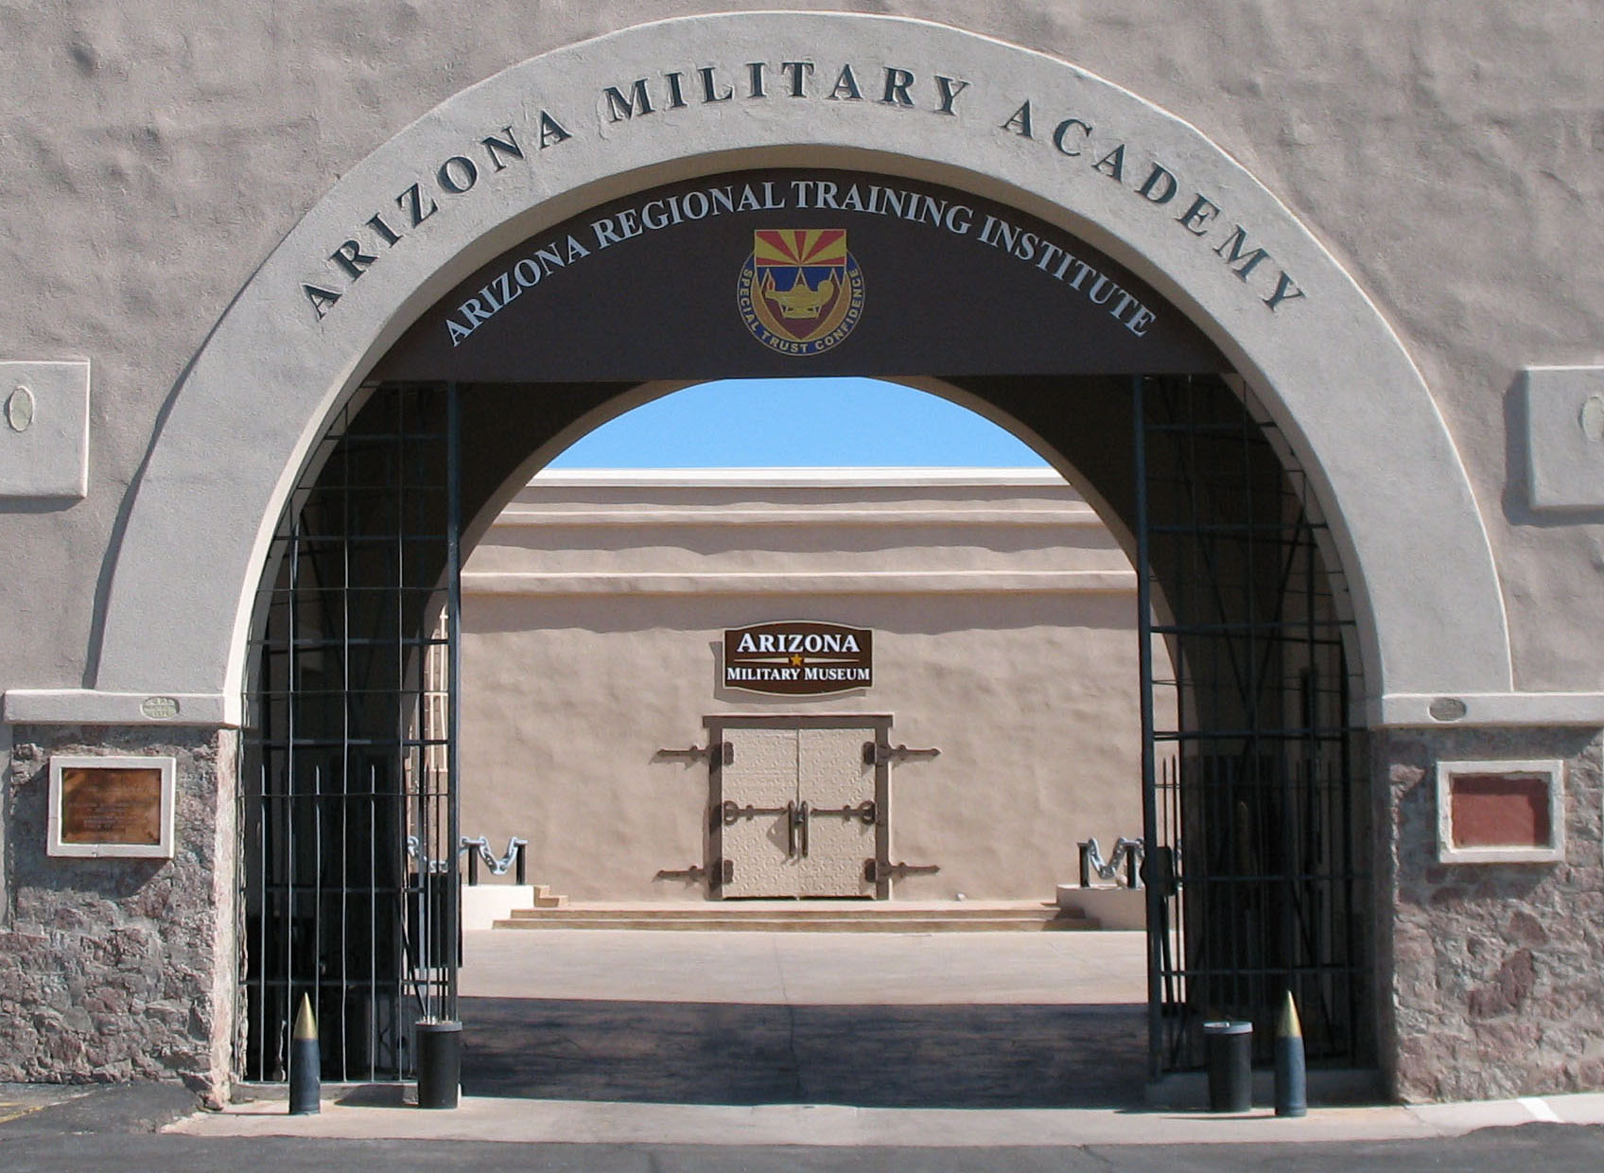
The Arizona Department of Veterans’ Services and the Arizona Military Museum are proud to co-host this 2nd annual dinner and event IN HONOR OF ARIZONA VIETNAM VETERANS.
This event is part of the 50th Commemoration of the Vietnam War activities whose first stated objective is:
To thank and honor veterans who served in the Vietnam War, including personnel who were held as prisoners of war or listed as missing in action, for their service and sacrifice on behalf of the United States and to thank and honor the families of these veterans.
We are honored to have as our very Special Guest Speaker, Lieutenant General, USA (Ret.) Mick Kicklighter, Director of the 50th Commemoration of the Vietnam War, and a two tour Vietnam veteran.
To all of you who served in the Vietnam war in country or on the coastal waters or in the AO (area of operation) working for or with supporting governmental agencies supporting the U.S. effort to prevent the Communist threat throughout the Republic of Vietnam and all of Southeast Asia…
This event is to honor you!
Colonel Joey Strickland, USA (Ret.), Director Colonel Joseph E. Abodeely, USA (Ret.)
Arizona Department of Veteran Services Director, Arizona Military Museum

